Planning Schools as Symbols of Change

Prakash Nair, REFP

Introduction

Tomorrow’s schools will reflect answers to two key questions. First, what is the most important condition for learning? And second, what are the most essential human qualities for success? Research now points to student engagement as the most important condition for learning and notes that social and emotional skills are more important determinants for success than technical expertise in any given area. To these findings we need to add the undeniable reality of a rapidly globalizing society where competition for jobs comes not from one’s neighbor or even a neighboring town but from across the continents – and from someone who is willing to do the same job for five times less money than one would expect to be paid in the U.S.

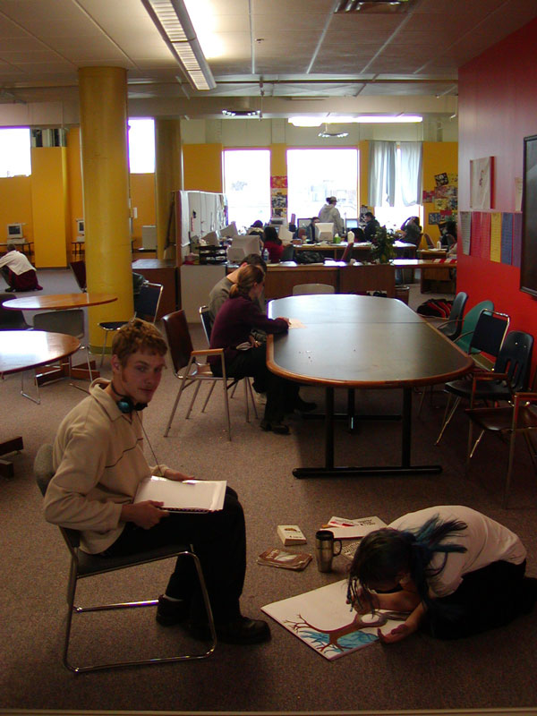
Today’s educational model must change because it is based upon uniformity – which goes against the grain of student engagement. Second, today’s model focuses so much on academic achievement that it leaves little room for the full development of social, emotional and other aspects of human potential, aspects that are key to success and happiness. Third, a changing global economy demands a level of training imbued with so much rigor and relevance that it renders today’s curriculums obsolete and irrelevant.
We are looking at an inevitable, major reengineering of the whole educational establishment. This trend is already evident in most exclusive private schools, in dozens of charter schools, in the vast advances made by the home-schooling movement and by at least a few of the more progressive public school systems like Seattle and Minneapolis. It is not inconceivable that in less than 10 years, the new student-centered model of education will predominate if not become mainstream.
Flexible learning space at Avalon School in Minneapolis, MN. Architect: Randall Fielding

These research-supported principles apply not only to the new global economic model, but also to certain essential human qualities largely unaffected by time.

Five Essential Components for Developing Effective School Facilities

There are five essential components that apply to the development of school facilities to which we can apply research and best practice-based principles. They are 1) Process, 2) Site Selection, 3) Building Design, 4) High Performance and 5) Post Occupancy. It will be useful to look at each of these areas to understand how tomorrow’s schools can become viable instruments of change.

1. Process

While most people tend to think about a school building as a product, effective learning environments are really a process. The word “process” is applicable to schools in two important ways. First, the process that is used to develop the school and second, the process of learning that the environment must support over an extended lifespan. A good process starts with involving as many stakeholders as possible during the early conceptual and planning stages of the school. For example, the Department of Education in Western Australia created a broadly representative Project Control Group (PCG) to be the key decision-making body on all matters pertaining to the planning, design and implementation of the new Canning Vale High School. The PCG was supported by technical working parties, each with community representation, working on issues such as curriculum, technology, and shared community facilities.

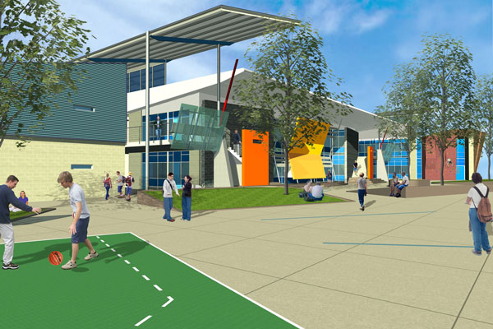
At the consulting end also, it is important to acquire a team that meets many requirements not traditionally required from school design teams. Looking once again at Canning Vale, here are the five qualifications that competing planning and design firms needed to
Canning Vale School, Western Australia, Project Developed through a Collaborative Planning and Design Process. Architect: Spowers/Vitetta. Planner: Prakash Nair
demonstrate – it is evident that these are not all typical requirements in the architect selection process:

- School design excellence
- An understanding of the connection between school facilities and learning outcomes
- Familiarity with the latest research in the field of education pertaining to the way children learn
- Experience engaging communities in the task of school planning
- Building consensus within a diverse stakeholder community

The purpose of the school development process is to shift the focus away from the building and toward the goals for the facility – to support the learning modalities of the 21st century, to serve as a center of community, to strengthen links between the education and business sectors, to provide a forum for continuing education, to support research, to partner with higher education institutions and so on. Such purpose-built schools will almost never look and feel like their traditional counterparts because they do not begin with the assumption that classrooms and corridors are the basic building blocks for every school.

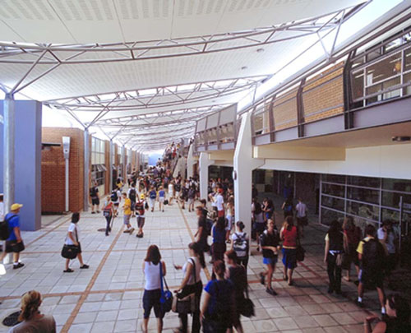
“An educated consumer is our best customer” used to be the popular advertising slogan of a large clothing chain. This is a very valid slogan for school planners today. No modern school should be planned without some attempt to “educate” the client community about research-supported
Learning Street – Peel Education and TAFE Campus Mandurah, Australia Spowers Architects
evidence connecting the built environment and learning outcomes. This can be done by facilitating a discussion around exemplar school designs from around the world in order to isolate aspects that may be transferable to the local context. But transference isn’t a one-way street. The purpose of real dialogue between and within the practitioner and stakeholder communities is to develop a shared vision for the school – one that will guide every aspect of its development. However, a vision should not be developed to the point where it becomes a prescription instead of a roadmap.

2. Site Selection

One of the problems that plagues the site selection process is that it commences after a decision has already been made about the school that will be built – often including a detailed program of spaces. A different approach would be to first find good sites for the school – “good” being defined here as places that are at the heart of communities, preferably within walking distance from where students live for elementary populations and within range of a diverse range of activities outside school for the middle and high school populations. Even the size of the site is not as important as its location. If you are looking to build one 600-student school and can only locate a marginal site in an industrial part of town, wouldn’t it be better to build two 300-student schools in converted commercial buildings or on infill sites in the heart of the community?
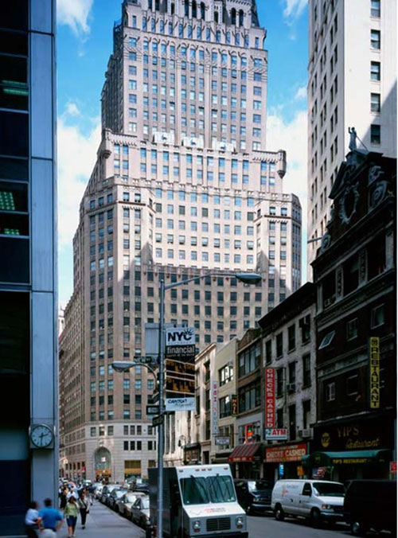
The Inter-District Downtown School in Minneapolis, the Harbor City International School in Duluth, Minnesota and Millennium High School near Ground Zero in New York City, are all located in existing, non-traditional commercial buildings, and each one takes advantage of the special attributes of being in these non-traditional buildings in locations where there is a rich interplay between the school and the surrounding community assets.
Millennium High School is housed in this Commercial Building near Ground Zero in New York City. Architect: HLW International, Planner: Fielding/Nair International

3. Building Design

Building design that is driven by too much pre-planning is almost as poor a way of eliciting good design as one that is too open-ended. But school clients are very leery of allowing design to proceed without all the ground rules being set in stone. Seattle has found a way to solve this problem by defining a set of design guidelines that are performance-based. The Seattle approach is to set the goals for design but not to limit the designer’s creativity. Here, for example, are a few performance-based guidelines that can be used to help create schools that work in certain contexts. Since each situation is different, such guidelines, tailored to the situation at hand, can be very helpful not only to the design team but also to the community evaluating the quality of the work that was done:

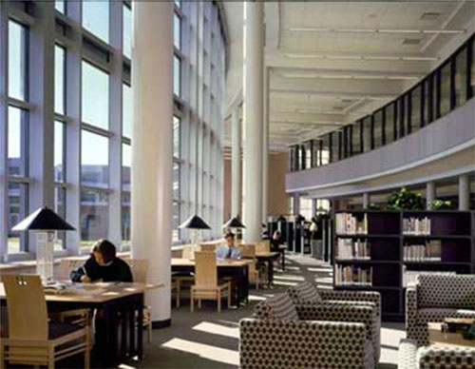
- Does the building layout respect the idea of creating small learning communities – preferably smaller than 150 students and 6 teachers within discrete “clusters”? Do these truly elicit a feeling of belonging or are they simply architectural sleights-of-hand that the actual school community will not recognize as distinct units?
- Are the primary developmental differences among children respected by separating very young children from the oldest kids?
- Has there been an attempt to reduce or eliminate long double-loaded corridors and replace them with highly articulated “learning streets”, “kivas” and other areas that encourage socializing, and provide opportunities for informal learning?
- Are the common and community use spaces designed and laid out so that they can be utilized before, during and after school hours without disrupting the academic areas (of course, in certain specialty schools, there would be little distinction between so-called “academic” and “non-academic” spaces, in which case this condition would not apply).
- Do all classrooms or other principal learning areas have adequate natural light and are classroom wings oriented in a predominantly east-west direction?
- Has the media center been located to maximize views, encourage reading and small group work?
- Are there comfortable areas within and around the school to encourage independent study and reading for pleasure?
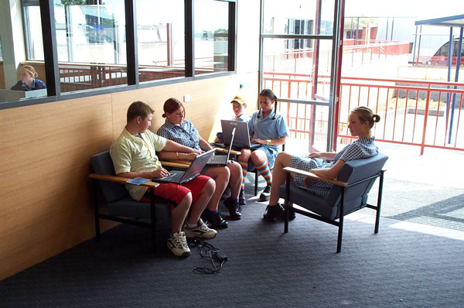
- Do children have access to food and beverages in formal as well as informal zones – “cafes” instead of cafeterias? Can children have access to food and beverages on demand or do they have to wait for set times in the day for refreshments?
- Is there anytime/anywhere access to appropriate educational technologies in the media center and within the rest of the school? Are mobile computers, wireless networking and distance learning elegantly integrated? Do classrooms have data projectors and are high-speed printers, powerful desktop PCs, scanners and plotters available for student use?
Anytime Anywhere Access to technology with wireless computing at Reece High School in Tasmania, Australia. Architect: Glenn Smith Associates. Planner: Prakash Nair
- Do kids have adequate areas outside classroom spaces to work with technology on their own and/or with others?
- Were opportunities to create outdoor learning areas maximized?
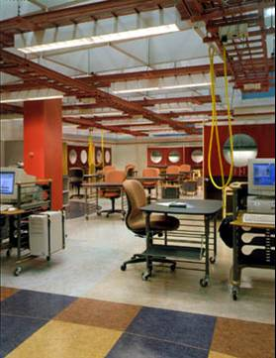
- Is the building design optimized toward maximizing opportunities for 21st century teaching and learning modalities (cooperative learning, advisories, team teaching, interdisciplinary curriculums, multi-age groupings, peer tutoring and project-based learning to name only a few?)
- Could the design be considered “flexible”? That means, does it allow users to reconfigure spaces as needed on a daily basis in the short term and is the building itself flexible to allow for more significant changes with time?
- Is the building design a good example of “intimate monumentality?” That means, it serves as an important community center with a strong visual and functional presence while at the same time being seen by its student community as an “intimate” non-institutional place? This applies less to certain schools that occupy commercial areas where the school makes no attempt to become a visible community landmark but rather becomes a seamless extension of the existing community itself.
Flexible Science lab at Grainger Center for Imagination and Inquiry at the Illinois Math and Science Academy Aurora, Illinois. OWP&P Architects
- Are “labs” and other specialty rooms designed with flexibility in mind? For example, are science labs laid out with fixed services like sinks and gas lines at the periphery with mobile work tables that can be used for hard science but rearranged at will for other project activities?
- Is there a “home base” for every student? In the higher grades this may be a workstation for each student and in the lower and middle grades this could be a dedicated cubby or locker.
4. High Performance

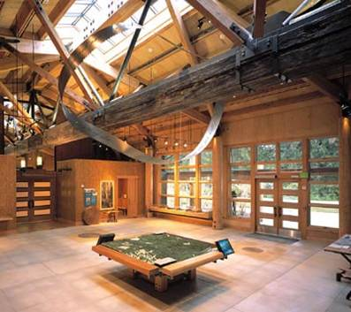
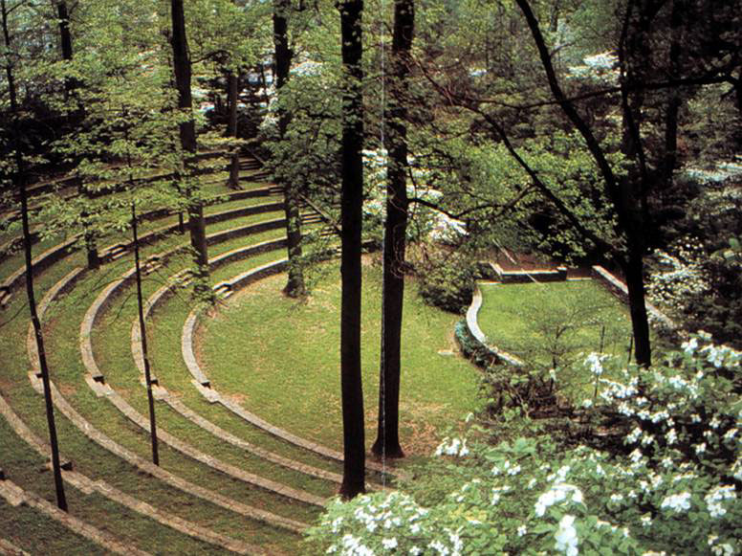
High performance design is not only about energy conservation and environmental sensitivity, but about an intelligent planning and design process. The idea is to utilize our knowledge about the connections between sustainable architecture and its impact on human physiology, psychology and behavior to design buildings that will improve learning outcomes as well as physical, spiritual and emotional well-being. This is a vast subject that cannot be adequately covered here, but the following publication provides clear guidelines for utilizing high performance principles in the design of schools: High Performance School Buildings, Resource and Strategy Guide published in 2001 by the Sustainable Buildings Industry Council. Valuable information is also available at the website of the U.S. Green Buildings Council (usgbc.org). The USGBC’s L.E.E.D. (Leadership in Energy and Environmental design) rating system is an excellent measure of a building’s qualitative and quantitative adherence to sustainable design.
Landscaped outdoor learning space at Swarthmore College. Architect: Ehrenkrantz, Eckstut and Kuhn
Island Wood School, Bainbridge Island, Washington maximizes the benefits of sustainable elements like daylight and natural ventilation and utilizes rainwater retention, photovoltaics, composting toilets and radiant floor heating. Mithun Architects.

5. Post-Occupancy

This is a significant area of weakness in most of this country’s school planning programs. The need for an effective post-occupancy evaluation is even more critical for schools that break the mold. Since there are few precedents for such schools, the POE can become a very useful tool to maximize the benefits of the built environment for the current users of a building and also to gather valuable feedback that can be used in the planning and design of future schools. When it comes to post-occupancy, there are two key questions that need to be asked:
- Have teachers and staff been exposed to an in-service training program to help them maximize the benefits of the new school facilities and facilitate the utilization of the building as a “3D-textbook” for students?
- Have the design expectations been realized – how does the building rate with the user community? (This step requires the preparation and implementation of a comprehensive post occupancy evaluation that is done a few months after the school opens).
Conclusion

We can say with some certainty that what is true about education is equally true about the buildings in which it is conducted. An argument can even be made that facilities need to be ahead of the educational systems curve. Being modern and futuristic means that buildings designed today need to remain relevant and useable many years from now. In fact, buildings can actually become catalysts and drivers of change – accelerating a process that may otherwise have taken much longer. It is not at all unusual for communities faced with the need to build new schools worth many millions of dollars to ask themselves where education is headed and design schools so that they are metaphorically “skating to where the puck is going and not to where it’s been” as a way of avoiding the bane of early obsolescence.
School buildings can become real symbols of change, but it is necessary to reengineer the process by which they are created for that to happen. With hundreds of books written about educational reform and dozens of articles about school planning, there is just too much information for most people engaged in creating schools to feel comfortable with. To this, we have to add the real problem of dealing with constant change and the checkered history of innovative school design which remains forever associated with the failed open classrooms experiment. In this context, it seems easier to stick with existing models which at least have an aura of comfortable familiarity about them than adopt new models with a questionable shelf-life.
The way out of this dilemma is to look at the research about the future of education, and by extension, the future of facilities, and planning schools around the kinds of enduring principles, such as those set forth in this paper, that define learning in the 21st century.

This article was originally published by the Council of Educational Facility Planners International’s Educational Facility Planner in December 2003. Prakash Nair is the President of Fielding/Nair International (FieldingNair.com), an award-winning school planning firm. He can be reached at Prakash@Designshare.com.

